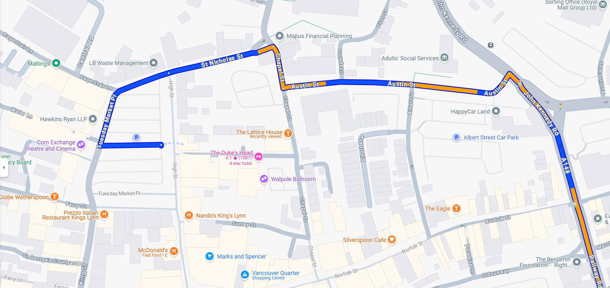
The Dukes Head….if you put the Dukes Head into google maps, it will take you to the car-park at the back of the hotel and it would be extremely tight for a coach. You need to drop off and pick-up INFRONT of the hotel. There is a large square with a road going around it and you can pull up immediately outside the hotel.
Try putting the Maids Head ( a pub) instead into google. Coach parking is 7 mins walk away , Austin Fields near Lidl.

