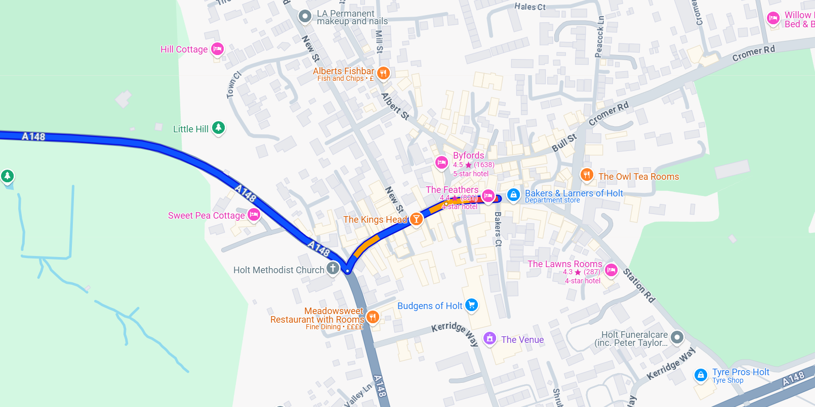
Holt
Drop off at a bus stop in Market Place then park up outside the town (coaches normally find a lay-by)
There is a bus stop near the Tourist Information shop ..

